**EXPERIMENT NO– 4**

**TITLE**: Inheritance

**1. Write a program in Java to create a Player class. Inherit the classes Cricket _Player, Football _Player and Hockey_ Player from Player class.**

**CODE**

**package** aviral;

**public** **class** c {

**public** **static** **void** main(String args[])

{

criket_player c=**new** criket_player("Ameer","criket",25);

football_player f=**new** football_player("arun","foot ball",25);

hockey_player h=**new** hockey_player("Ram","hockey",25);

c.show();

f.show();

h.show();

}

}

**class** Player

{

String name;

**int** age;

Player(String n,**int** a)

{ name=n; age=a; }

**void** show()

{

System.***out***.println("\n");

System.***out***.println("Player name : "+name);

System.***out***.println("Age : "+age);

}

}

**class** criket_player **extends** Player

{

String type;

criket_player(String n,String t,**int** a)

{

**super**(n,a);

type=t;

}

**public** **void** show()

{

**super**.show();

System.***out***.println("Player type : "+type);

}

}

**class** football_player **extends** Player

{

String type;

football_player(String n,String t,**int** a)

{

**super**(n,a);

type=t;

}

**public** **void** show()

{

**super**.show();

System.***out***.println("Player type : "+type);

}

}

**class** hockey_player **extends** Player

{

String type;

hockey_player(String n,String t,**int** a)

{

**super**(n,a);

type=t;

}

**public** **void** show()

{

**super**.show();

System.***out***.println("Player type : "+type);

}

}

**OUTPUT**

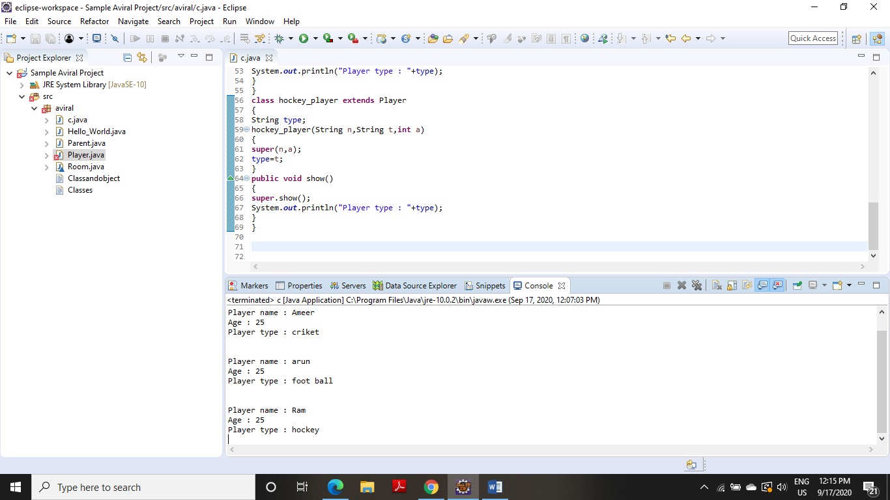

**2. Write a Java program to show that private member of a super class cannot be accessed from derived classes.**

**CODE**

**package** aviral;

**public** **class** R

{

**public** **static** **void** main(String args[])

{

class_room cr=**new** class_room(10,20,15);

**int** a1=cr.area();

**int** v1=cr.volume();

System.***out***.println("Area of Room : "+a1);

System.***out***.println("Volume of Room : "+v1);

}

}

**class** room

{

**private** **int** l,b;

room(**int** x,**int** y)

{ l=x; b=y;}

**int** area()

{**return**(l*b);

}

}

**class** class_room **extends** room

{

**int** h;

class_room(**int** x,**int** y,**int** z)

{

**super**(x,y);

h=z;

}

**int** volume()

{

**return**(area()*h);

}

}

**OUTPUT**

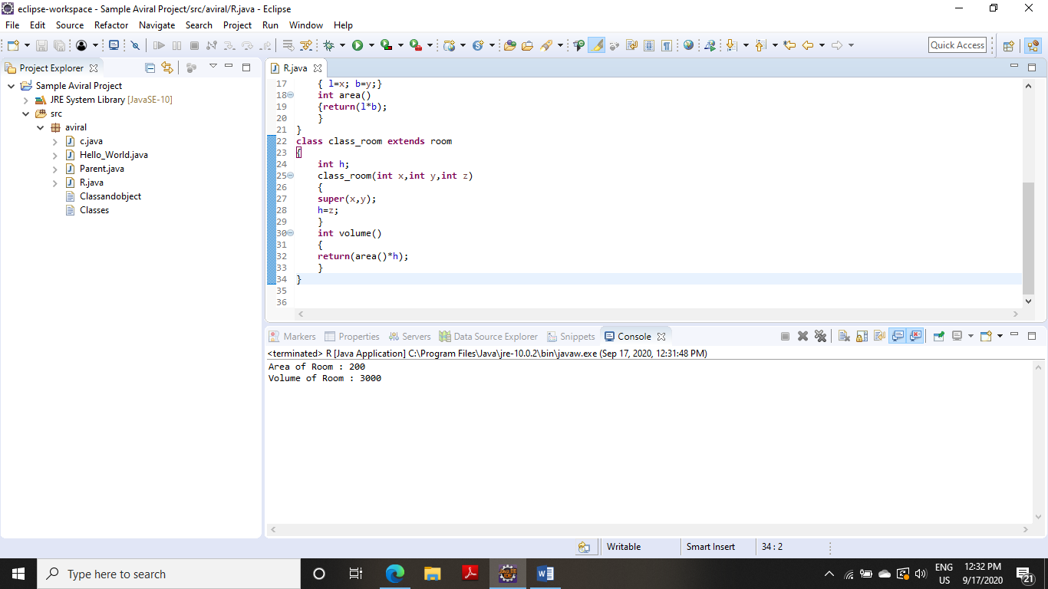

**3. Write a class Worker and derive classes DailyWorker and SalariedWorker from it. Every worker has a name and a salary rate. Write method ComPay (int hours) to compute the week pay of every worker. A Daily Worker is paid on the basis of the number of days he/she works. The Salaried Worker gets paid the wage for 40 hours a week no matter what the actual hours are. Test this program to calculate the pay of workers. You are expected to use the concept of polymorphism to write this program.**

**CODE**

**package** aviral;

**class** W

{

**public** **static** **void** main(String args[])

{

dailyworker d=**new** dailyworker(254,"Arjun",75);

salariedworker s=**new** salariedworker(666,"Unni",100);

d.compay(45);

s.compay();

}

}

**class** worker

{

String name;

**int** empno;

worker(**int** no,String n)

{ empno=no; name=n; }

**void** show()

{

System.***out***.println("\n--------------------------");

System.***out***.println("Employee number : "+empno);

System.***out***.println("Employee name : "+name);

}

}

**class** dailyworker **extends** worker

{

**int** rate;

dailyworker(**int** no,String n,**int** r)

{

**super**(no,n);

rate=r;

}

**void** compay(**int** h)

{

show();

System.***out***.println("Salary : "+rate*h);

}

}

**class** salariedworker **extends** worker

{

**int** rate;

salariedworker(**int** no,String n,**int** r)

{

**super**(no,n);

rate=r;

}

**int** hour=40;

**void** compay()

{

show();

System.***out***.println("Salary : "+rate*hour);

}

}

**OUTPUT** 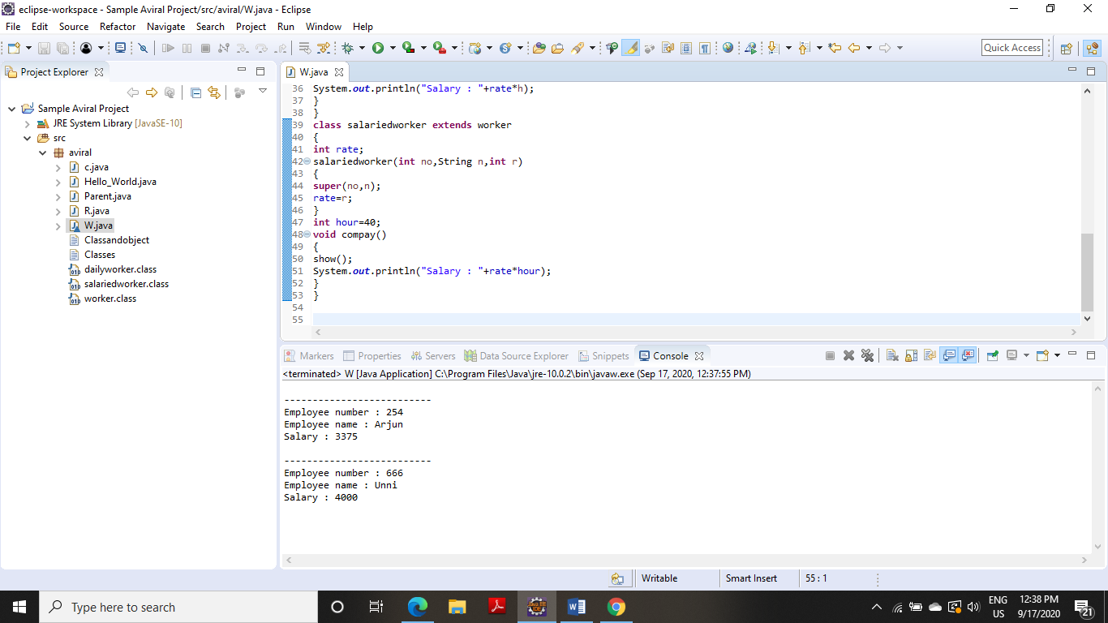

**4. Consider the trunk calls of a telephone exchange. A trunk call can be ordinary, urgent or lightning. The charges depend on the duration and the type of the call. Write a program using the concept of polymorphism in Java to calculate the charges.**

**CODE**

**import** java.util.Scanner;

**class** Telephone{

**int** callnumber;

String calltype;

Telephone(**int** c,String s){

callnumber = c;

calltype = s;

}

**void** show() {

System.***out***.println("call number"+" "+callnumber);

System.***out***.println("call type"+" "+calltype);

}

}

**class** Ordinary **extends** Telephone{

**float** cost;

Ordinary(**int** c,String s,**float** co){

**super**(c,s);

**this**.cost = co;

}

**void** charge(**double** time) {

**super**.show();//calling show() of parent class

System.***out***.println("call charges"+" "+cost*time);

}

}

**class** Urgent **extends** Telephone{

**float** cost;

Urgent(**int** c,String s,**float** co){

**super**(c,s);

**this**.cost = co;

}

**void** charge(**double** time) {

**super**.show();

System.***out***.println("call charges"+" "+cost*time);

}

}

**class** Lightening **extends** Telephone{

**float** cost;

Lightening(**int** c,String s,**float** co){

**super**(c,s);

**this**.cost = co;

}

**void** charge(**double** time) {

**super**.show();

System.***out***.println("call charges"+" "+cost*time);

}

}

**public** **class** Exp_4_4 {

**public** **static** **void** main(String[] args) {

// **TODO** Auto-generated method stub

Scanner sc=**new** Scanner(System.***in***);

**int** a,no;

**double** t;

System.***out***.println("Enter 1 for ordinary call,2 for urgent call or 3 for lightening call");

a=sc.nextInt();

**switch**(a) {

**case** 1:

System.***out***.println("Enter the number to which call is to be made");

no=sc.nextInt();

Ordinary obj1 = **new** Ordinary(no,"ordinary call",3);

System.***out***.println("Enter the duration of the call");

t=sc.nextDouble();

obj1.charge(t);

**break**;

**case** 2:

System.***out***.println("Enter the number");

no=sc.nextInt();

Urgent obj2=**new** Urgent(no,"Urgent call",4);

System.***out***.println("Enter the duration of the call");

t=sc.nextDouble();

obj2.charge(t);

**break**;

**case** 3:

System.***out***.println("Enter the number");

no=sc.nextInt();

Lightening obj3 = **new** Lightening(no,"Lightening call",5);

System.***out***.println("Enter the duration of the call");

t=sc.nextDouble();

obj3.charge(t);

}

}

}

**OUTPUT**

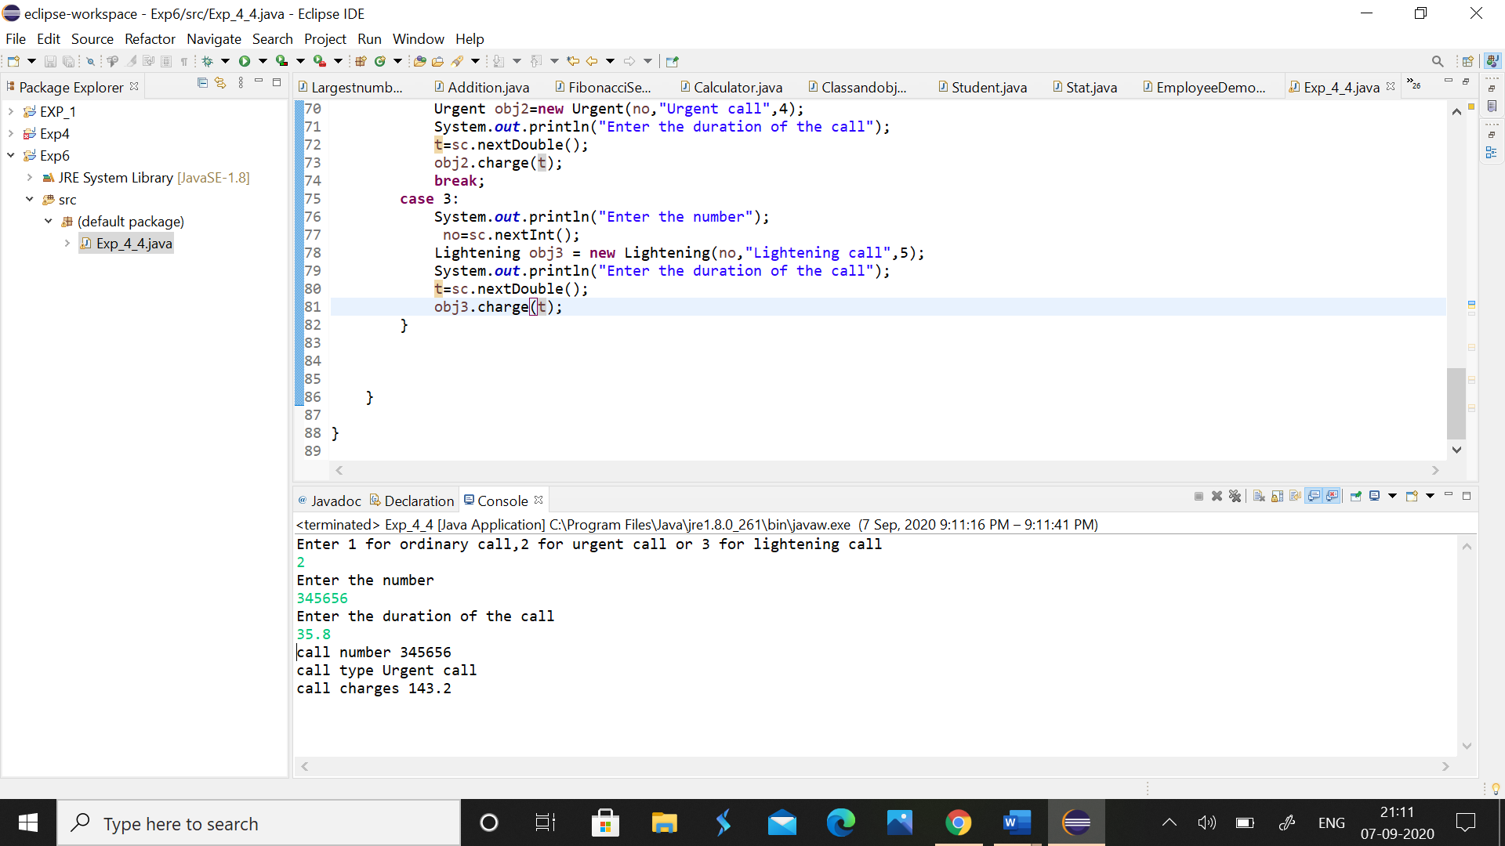

**5. Design a class employee of an organization. An employee has a name, empid, and salary. Write the default constructor, a constructor with parameters (name, empid, and salary) and methods to return name and salary. Also write a method increaseSalary that raises the employee’s salary by a certain user specified percentage. Derive a subclass Manager from employee. Add an instance variable named department to the manager class. Supply a test program that uses theses classes and methods**.

**CODE**

**import** java.util.Scanner;

**class** Employee{

**int** empid;

String name;

**double** salary;

Employee(){

System.***out***.println("This is employee default constructor");

}

Employee(**int** emid,String name,**double** salary){

**this**.empid = emid;

**this**.name = name;

**this**.salary = salary;

}

String name()

{

**return** name;

}

**double** salary()

{

**return** salary;

}

**void** increase_salary(**int** i) {

**double** x;

x=((salary*i)/100)+salary;

System.***out***.print("Increased salary ="+" "+x);

}

}

**class** Manager **extends** Employee{

String department;

Manager(**int** e,String n,**double** sal,String d){

**super**(e,n,sal);

department = d;

}

**void** display() {

Scanner sc=**new** Scanner(System.***in***);

System.***out***.println("Name of the employee"+" "+**super**.name());

System.***out***.println("salary of a employee"+" "+**super**.salary());

System.***out***.print("department is"+ " "+ department+"\n");

System.***out***.println("Enter the percentage by which a salary is to be increased");

**int** ps=sc.nextInt();

**super**.increase_salary(ps);

}

}

**public** **class** Exp_5_5 {

**public** **static** **void** main(String[] args) {

Scanner sc=**new** Scanner(System.***in***);

System.***out***.println("Enter the name of the employee");

String name=sc.nextLine();

System.***out***.println("Enter the id of the employee");

**int** id=sc.nextInt();

System.***out***.println("Enter the salary of the employee");

**double** sal=sc.nextDouble();

Manager M = **new** Manager(id,name,sal,"CS");

M.display();

}

}

**OUTPUT**

